**Chapter 9 exercise – enabling dedup on Windows Server 2019**

In this chapter's exercise, you will learn how to enable dedup on Windows Server 2019.

## Enabling dedup on Windows Server 2019

To enable dedup in Windows Server 2019, complete the following steps:

1. Click **Add roles and features** within the **Server Manager** | **WELCOME TO SERVER MANAGER** section.
2. On the **Before You Begin** window, click **Next.**
3. Click **Next** on the **Installation Type** window.
4. On the **Server Selection** window, click **Next.**
5. On the **Server** **Roles** window, expand **File and Storage Services.**
6. Then, expand **File and iSCSI Services.**
7. Select **Data Deduplication**, as shown in *Figure 9.7*.
8. On the **Features** window, click **Next.**
9. On the **Confirmation** window, click **Install.**
10. When you see the installation has completed, click **Close**, as shown in *Figure 9.19*:

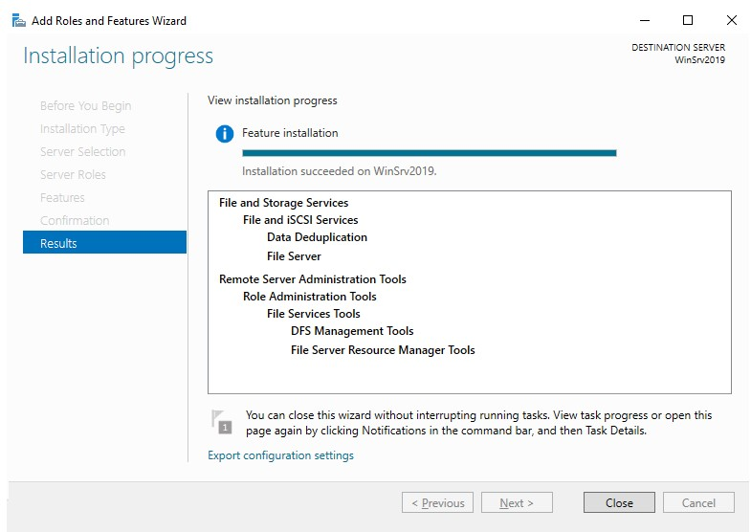

Figure 9.19: Closing the Add Roles and Features Wizard

This exercise has shown us how dedup can be installed on Windows Server 2019.